Data Dictionary
Name | Data Type | Size | Sample
price | Decimal | About 4 decimals | 22.33

Testing Table
Object | Input | Expected Output | Actual Output
btnCalculate | 50 Quantity | A message reminding to put in style and size | 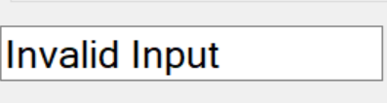  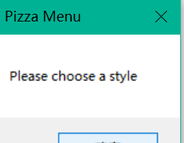
btnCalculate | Pick up 9 large Meat Lovers | $162.00 | 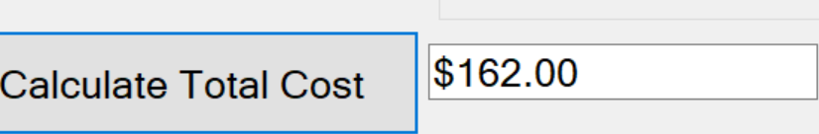
btnClear | Pick up 9 large Meat Lovers | All objects clear. | 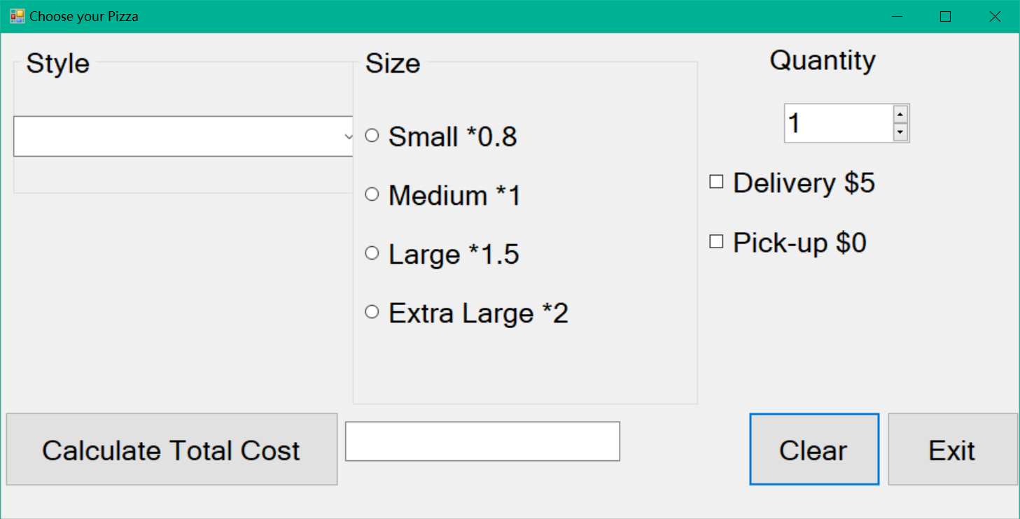
btnExit | N/A | Exit | Exit

